Developing Chat Server For Addressing FAQ’s about Creative Learning

# Shridhar Joshi

*Department of Information Technology*

*A.P Shah Institute of Technology*

Thane, India [19104034@apsit.edu.in](mailto:19104034@apsit.edu.in)

# Anagha Aher

Akshada Warik

*Department of Information Technology*

*A.P Shah Institute of Technology*

Thane, India [19104042@apsit.edu.in](mailto:19104042@apsit.edu.in)

# Harsh Rathod

*Department of Information Technology*

*A.P Shah Institute of Technology*

Thane, India [19104057@apsit.edu.in](mailto:19104057@apsit.edu.in)

# Jayshree Jha

*Department of Information Technology*

*A.P Shah Institute of Technology*

Thane, India [anaher@apsit.edu.in](mailto:anaher@apsit.edu.in)

*Department of Information Technology*

*A.P Shah Institute of Technology*

Thane, India [jpjha@apsit.edu.in](mailto:jpjha@apsit.edu.in)

***Abstract*—During the pandemic, rapid growth in online learn- ing and educational platforms has been seen. However, the major problem faced by the learners is that they were missing the student-teacher interaction as well as peer-to-peer interaction. To cover up this gap, features like forums, live chat, etc. were introduced. In this project, we will be building a live chat server using Node.js, Express.js, and socket.io. One thing that is observed in these online learning platforms is that the users may not always consider the sentiments and feelings of other users present on the live server. To prevent the use of slang, vulgar language, and inappropriate words, we would be using an analysis bot that will scan for such inappropriate words and if found, the message will be highlighted and will not be uploaded to the server unless corrected. This helps to maintain the quality of chats on the website considering that the website is meant to be a learning platform where users from various backgrounds, age groups, and nationalities will be present. Sentiment analysis, Data Mining, and Natural Language Processing will be used to analyze the message. The degree of the inappropriateness of the text message will be calculated based on the classification of words done using the Naive-Bayes Classifier.**

***Index Terms*—live server, offensive language detection, generative chatbot, Decision Tree, analysis bot**

1. INTRODUCTION

In the modern world, the need for Technological Advance- ments has paved the way for new miracles in mankind. Arti- ficial intelligence has played a veritably pivotal part in these technological advancements. In recent times live chat systems have gained fashionability because of their wide operations. From the client’s point of view, live converse systems present a unique experience of the vacuity of help and support any time of the day.

As the name implies, a dedicated live chat server is a live chat service that is only for you. A computer that controls access to your live chat channel is known as a live chat server. When anything is devoted to you, it means that it solely hosts your live chat service. No other company can access the server, and they don’t host their chat there either. However, why would you possibly want to employ a dedicated live chat server?

Here, we look at a few advantages of running your live chat channel on a dedicated server

The technique of turning unstructured text into organized data for quick examination is called text mining. Text mining employs natural language processing (NLP), which enables computers to comprehend and automatically interpret human language. The massive amount of data produced each day by organizations is both an opportunity and a difficulty. On the one hand, data offers businesses wise insights into what customers think about a certain good or service. Consider all the possible ideas you may discover by looking through emails, product evaluations, social media postings, customer reviews, support requests, etc. On the flip side, there is the conundrum of how to handle all this data. And here is where text mining is so important. A machine learning technique called text analysis (TA) is used to automatically uproot useful information from unstructured text input. Text analysis tools are used by businesses to swiftly consume web data and documents and turn them into useful perceptivity. Using text analysis, you may sort and check replies by station and subject or extract particular data from knockouts of thousands of emails, analogous as names, company names, or keywords.

Any communication that can be construed as objection- able morally, socially, religiously, or culturally is considered offensive if it uses foul language, swears, or uses racial phrases or material. The language that is rude or abusive is a persistent problem in all prominent social networking sites. Online users have been noted to face these problems very frequently. Although there isn’t currently a cure for this unwelcoming habit, Major E-learning platforms have begun to develop strategies for minimizing crude language.

The paper is structured as follows. In the upcoming section, a Literature review of the related works in offensive language detection and online chat server in educational platforms has been shown. The methodology section presents the different methods used to make this a working project. In section

4, the proposed system with the workflow of the system. Section 5 contains detailed information regarding the implementation of our system. The conclusion and future scope discuss the future additions that can be done to the project and concludes the paper.

1. LITERATURE REVIEW

This section includes past researches on Developing Chat Server For Addressing FAQ’s about Creative Learning and related topics to the latter, and also give brief about their researches, implementation and deployment.

By examining the types of foul language used in comments made by users on Software Engineering (SE) platforms Jithin Cheriyan in 2021 proposed A Conflict Reduction System (CRS) [1] which first analyzes offense before outlining po- tential modifications that might be done to lessen offense.

The chatbot created by E.Kasthuri in 2021 can answer the students with exact answers. Students can ask a question in the chatbot in the form of text, then the question is processed with natural language processing and deep learning technology. This chatbot can solve [3] student doubts at any time without human support.

Using Deep Learning, Natural Language Processing, Sen- timent Analysis, and Text Mining V.Selina Annie Retna et al proposed a system that is intended to perform flirt analysis and time analysis. This project also makes it possible to determine the quantity of positive and negative phrases [9] each individual uses. This will make it easier to assess the person’s mental condition.

According to R.S. Ramya et al research, in the year 2021, they created a deep learning model that is utilized to process the user remarks and to create a potential user rating for user comments. The suggested model [8] uses wordnet sentiment analysis to identify the terms and deep learning to predict user ratings from user comments.

Using machine learning methods such as Naive Bayes Classifier and Support Vector Machine, In the year 2020, Thae Ma Ma made a project which will classify [5] emails into spam or legitimate based on the body or content of the emails.

The proposed system by Pankaj Choudhary et al in the year 2020, can be used to measure the similarity of the model answer with the posted answer of the student to discuss the topic [2] and their relevance. A similarity measure is calculated, using pattern matching, and content analysis for assigning the grade to the student’s answer and the result is compared with the teacher’s grade which shows significant results. With the help of pattern matching, the model answer string is compared with the student’s answer and similarity is calculated.

The process of text learning,text analysis learning models are analyzed by Liu Yingi, using deep learning in the year 2020. It also includes convolutional neural networks, recurrent neural networks, deep learning algorithm fusion [11], and so on.

The Chatbot implemented by Prof Shabana Tadvl in the year 2020 will reply to queries 24/7 in real time using Natural

Language Processing, Natural Language Understanding, and SQL Server Management Studio. The Chatbot will be able to create a query list, which will help in understanding the areas

[10] that need to be improved.

The research conducted by Tatwadarshi P. Nagarhalli in 2020 contains a detailed study of some of the recent chatbot systems/papers developed in different domains.They found that chatbot systems have evolved into a highly practical means for understanding contemporary trends in the development of chatbots [6] and interacting with the public.

The study conducted by Nithuna S in 2020 offers a critical analysis of chatbots and the present tactics that are in-depth in- vestigated. The system is executed by a variety of lightweight AIML files [7] and packages that are extra versatile and interactive for practice in a variety of subjects.

The potential for educational chatbots to assist students, instructors, and other staff members are enormous. By utilizing the Sequence-to-Sequence model with Attention Mechanism- based [4] RNN encoder-decoder model in 2020, Naing Naing Khin investigated the methods of communication through neural network chatbots. The chatbot provides information about the university to students, teachers, and others.

1. METHODOLOGY

Understanding the working of a project is very important before making it live. As explained earlier Live-chat server and Forums play an important role in building of a website based on creative learning. It enables the user to get solutions for their difficulties which are specific to user experience.

The user will login using their respective account, followed by he/she can click on the chat-bot to activate it and enter their doubts/queries. The bot will generate an answer which it may seem as the relevant solution. If the users are satisfied with the solution, they can close the chat bot. If not, they will be provided with an option to be redirected to the live-chat server where their peers or the instructor can resolve their queries.

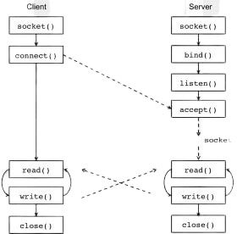

Fig. 1. Working of Socket.io

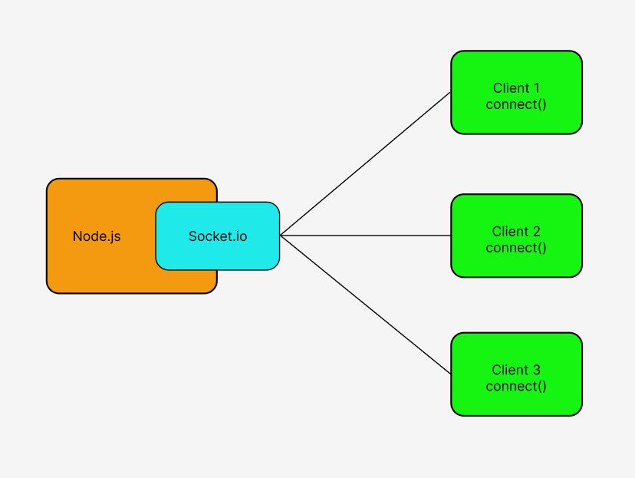

Fig. 2. Socket.io allowing multiple clients to connect to a single server

To enhance the functionality of our chat server, we will utilize Node, Express, and Socket. Using his or her login, the user will sign up. Before the user’s query or answer is uploaded to the live chat, it will first pass through our analysis bot when the user inputs it and clicks the “send” button.

1. PROPOSED SYSTEM

Users are linked in real time through the live-chat server. This server, or group of servers, is in charge of securely receiv- ing a message, determining its intended destination, queuing it, and then sending it on to the recipient’s chat client. Given all these factors, we constructed this live chat server utilizing a REST API, a WebSocket server, Node, and Express.

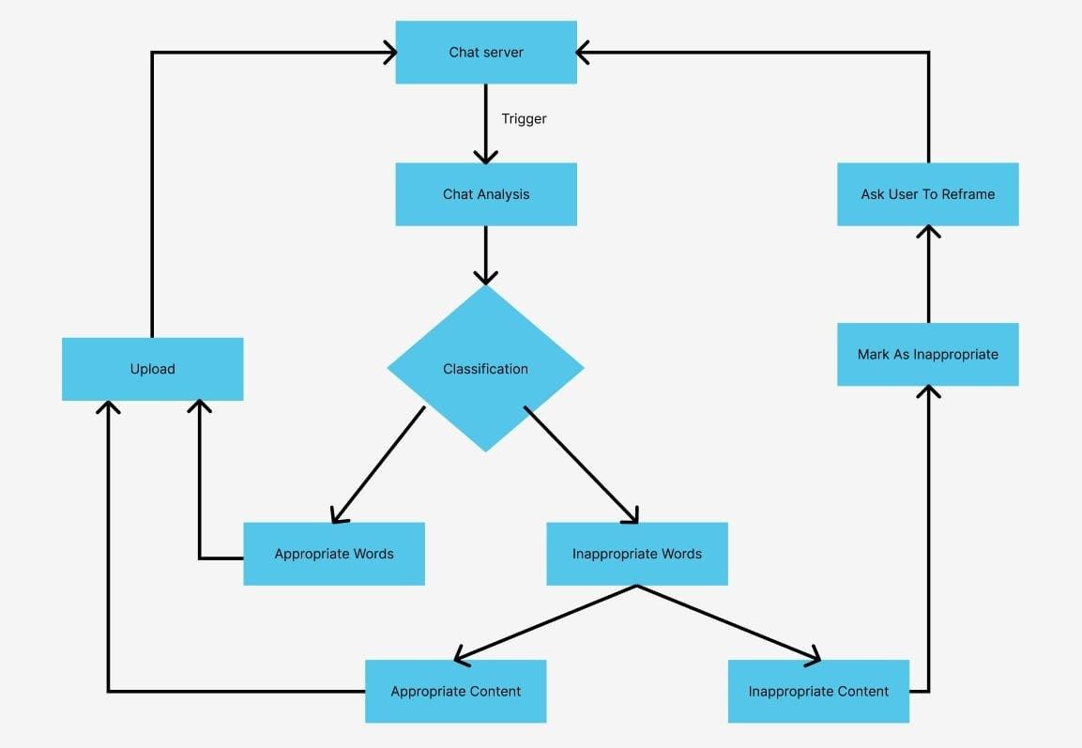

Fig. 3. Flow Chart of analysis bot

An online community forum is created using React where teachers and students can congregate, ask questions, solve queries, receive peer-to-peer support, discuss their similar interests, and make social connections.

A Generative chatbot is developed that generates original combinations of language rather than selecting from prede- fined responses. The chatbot is trained using Multinomial

Naive Bayes so that it can generate answers based on the questions asked and take the previous context well into account. The effectiveness of Generative chatbots can easily be leveraged to deliver a great customer experience.

1. IMPLEMENTATION

The landing page gives the user the option to select the chat room you want to join along with your username. This is the username that will be visible on the live-chat so that the users can identify each other.

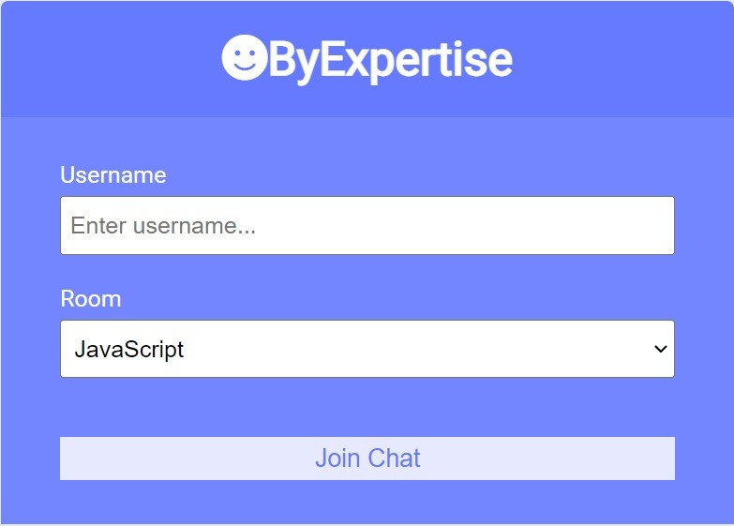

Fig. 4. Selection Of Chat Room

The educational based live chat server answers the repetitive questions and queries with diligence as their processes involve such interrogation. There is no need for the students to consult any other tool or platform because the chat server delivers accurate and instant answers to queries along with the name of the user and timestamp.

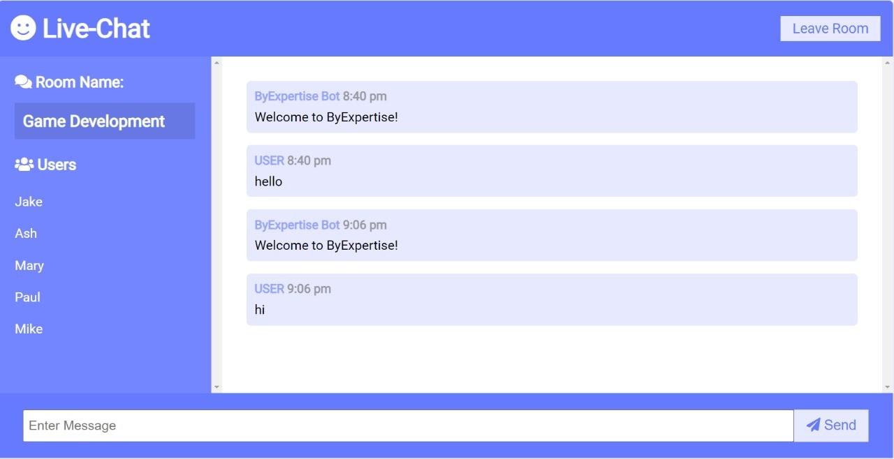

Fig. 5. Entering Live Chat Server

Whenever a client connects or disconnects, it is displayed on the chat so that the other users can know who left the chat. This can be helpful to understand whether the instructor or the peer answering the queries is active on the chat server or not.

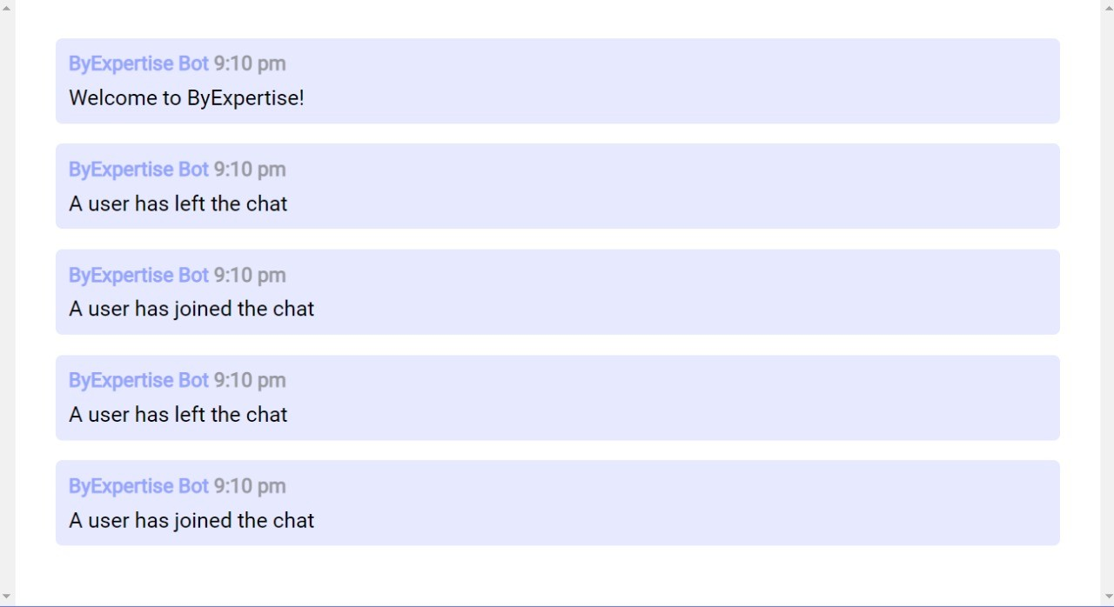

Fig. 6. Real Time Notification of Users Leaving and Entering the Server

The user text will be sent from the Live chat server to the analysis bot for reviewing. If no offensive language is detected, the text will be displayed on the live server. Otherwise, the text would not be posted on the live chat server and the user will be asked to rephrase their text in an acceptable form.

1. CONCLUSION AND FUTURE SCOPE

The system uses a deep learning approach to build this educational chat server. As the number of e-learners is in- creasing nowadays, It is observed that the learners tend to be informal and use abusive words. The system which we have developed is a abuse detection bot which helps to identify and minimize offensive contents in online learning platforms. The goal of this study was to identify and categorize foul language in online learning platforms in order to decrease unfavorable posts by alerting the author to the offensive content and offering potential substitutes. We have created a generative chatbot that responds automatically, is available constantly, and also saves time by reducing the need for human interaction. With the use of specialized software, chatbots may simulate human-to-human communication while really responding with automated responses. The chatbot assists students, professors, and anybody else looking for information about a certain course. Using the most recent technologies, a real-time chat server is created. The system’s primary benefits include group chat, instant messaging, and real-world contact. Students may quickly receive answers to their questions by using our live chat service. Users may communicate easily thanks to the real-time chat server.

In the future, our model may be built in such a manner that the chatbot can provide multilingual replies in many languages and be trained further with new datasets in other languages. Teachers and students can see each other and work together to find answers by adding a new feature of video calling and video conferencing. Features for voice recording can be added. The audio of the individual participating in the video conference may be captured for analysis and training reasons. The derogatory language used during video conferences can be recognized. It is possible to improve the system further for more precision and a solution.

REFERENCES

1. Jithin Cheriyan, Bastin Tony Roy Savarimuthu, and Stephen Cranefield. Towards offensive language detection and reduction in four software engineering communities. In *Evaluation and Assessment in Software Engineering*, pages 254–259. 2021.
2. Pankaj Choudhary and R Shriram. Short answer type discussion forum analysis and assessment. In *2020 International Conference for Emerging Technology (INCET)*, pages 1–3. IEEE, 2020.
3. E Kasthuri and S Balaji. A chatbot for changing lifestyle in education. In *2021 Third International Conference on Intelligent Communication Technologies and Virtual Mobile Networks (ICICV)*, pages 1317–1322. IEEE, 2021.
4. Naing Naing Khin and Khin Mar Soe. Question answering based university chatbot using sequence to sequence model. In *2020 23rd Conference of the Oriental COCOSDA International Committee for the Co-ordination and Standardisation of Speech Databases and Assessment Techniques (O-COCOSDA)*, pages 55–59. IEEE, 2020.
5. Thae Ma Ma, Kunihito Yamamori, and Aye Thida. A comparative approach to na¨ıve bayes classifier and support vector machine for email spam classification. In *2020 IEEE 9th Global Conference on Consumer Electronics (GCCE)*, pages 324–326. IEEE, 2020.
6. Tatwadarshi P Nagarhalli, Vinod Vaze, and NK Rana. A review of current trends in the development of chatbot systems. In *2020 6th International Conference on Advanced Computing and Communication Systems (ICACCS)*, pages 706–710. IEEE, 2020.
7. S Nithuna and CA Laseena. Review on implementation techniques of chatbot. In *2020 International Conference on Communication and Signal Processing (ICCSP)*, pages 0157–0161. IEEE, 2020.
8. RS Ramya, K Sandhya, KR Venugopal, SS Iyengar, and LM Patnaik. Real time emotion support system in text mining [rtestm]. In *2021 International Conference on Computer Communication and Informatics (ICCCI)*, pages 1–4. IEEE, 2021.
9. V Selina Annie Retna, P Brundha, and G RajKumar. People’s behaviour analysis in chat message using natural language processing. In *2021 Third International Conference on Intelligent Communication Technolo- gies and Virtual Mobile Networks (ICICV)*, pages 1128–1133. IEEE, 2021.
10. Shabana Tadvi, Sultanat Rangari, and Ammar Rohe. Hr based interactive chat bot (powerbot). In *2020 International Conference on Computer Science, Engineering and Applications (ICCSEA)*, pages 1–6. IEEE, 2020.
11. Liu Ying and Li Huidi. Review of text analysis based on deep learning. In *2020 International Conference on Intelligent Computing and Human- Computer Interaction (ICHCI)*, pages 384–388. IEEE, 2020.
12. K. M. Subash, L. P. Kumar, S. L. Vadlamani, P. Chatterjee and O. Baysal, "DISCO: A Dataset of Discord Chat Conversations for Software Engineering Research," 2022 IEEE/ACM 19th International Conference on Mining Software Repositories (MSR), Pittsburgh, PA, USA, 2022, pp. 227-231, doi: 10.1145/3524842.3528018.
13. D. Chakraborty, A. Mishra, V. Kumar, S. Singh and H. Hani, "VOID - An Assistant (Chatbot) to Education Queries System," 2022 International Conference on Advancements in Smart, Secure and Intelligent Computing (ASSIC), Bhubaneswar, India, 2022, pp. 1-6, doi: 10.1109/ASSIC55218.2022.10088400.
14. G. S. Sai Vikas, I. D. Kumar, S. A. Shareef, B. R. Roy and G. Geetha, "Information Chatbot for College Management System Using Multinomial Naive Bayes," 2021 2nd International Conference on Smart Electronics and Communication (ICOSEC), Trichy, India, 2021, pp. 1149-1153, doi: 10.1109/ICOSEC51865.2021.9591757.
15. R. Vannala, S. B. Swathi and Y. Puranam, "AI Chatbot For Answering FAQ’s," 2022 IEEE 2nd International Conference on Sustainable Energy and Future Electric Transportation (SeFeT), Hyderabad, India, 2022, pp. 1-5, doi: 10.1109/SeFeT55524.2022.9908774.